**Statement of Years Missing in Transcript**

Dear Madam or Sir,

I write this statement to explain the problem of years missing in my undergraduate transcript. My undergraduate programme is Bachelor of Science major in Computer Science which is a three-year full time programme. I enrolled in this programme in July 2017 and schedule to graduate in June 2020 by the programme schedule. However, I have overloaded two of my normal semesters and attended both summer semesters of 2017 and 2018. Therefore, I will achieve the requirement of my programme in two years and I will finish my undergraduate programme in June 2019.

By the university rule, every student can study 8 units (usually means 4 courses) in a normal semester i.e. semester 1 or 2 of that year. Besides, students with GPA over 4.5 can enroll two more units every normal semester. Moreover, summer semester (around three months from mid-November to mid-February in following year) is available for UQ students that allows 6 units at most if they have school permission. Finally, 48 units are required for my programme which usually composed of 24 courses.

I entered UQ in semester 2 of 2017 and I enrolled 4 courses (8 units) in the first semester. Then I learnt three courses (6 units) in summer semester of 2017. In 2018, I enrolled 5 courses (10 units) in both semester 1 and 2. Besides, I also studied 3 courses (6 units) in summer semester of 2018. Finally, I current attend 4 courses (8 units) in semester 1 of 2019. Therefore, I will finish my undergraduate programme in June 2019.

|  |  |  |
| --- | --- | --- |
| Semester | Programme Schedule  of Computer Science in UQ | My Personal Timetable |
| Semester 2, 2017 | 4 courses (8 units) | 4 courses (8 units) |
| Summer semester, 2017 |  | 3 courses (6 units) |
| Semester 1, 2018 | 4 courses (8 units) | 5 courses (10 units) |
| Semester 2, 2018 | 4 courses (8 units) | 5 courses (10 units) |
| Summer semester, 2018 |  | 3 courses (6 units) |
| Semester 1, 2019 | 4 courses (8 units) | 4 courses (8 units) |
| Semester 2, 2019 | 4 courses (8 units) |  |
| Summer semester, 2019 |  |  |
| Semester 1, 2020 | 4 courses (8 units) |  |
| Graduate | 24 courses (48 units) | 24 courses (48 units) |

Table: comparison between UQ schedule and my personal timetable

My course list by year can be find in appendix which comes from the University of Queensland.

Hope this statement can be helpful for you.

Kind regards

Hongwei Li

Appendix 1: Course enrolled in 2017

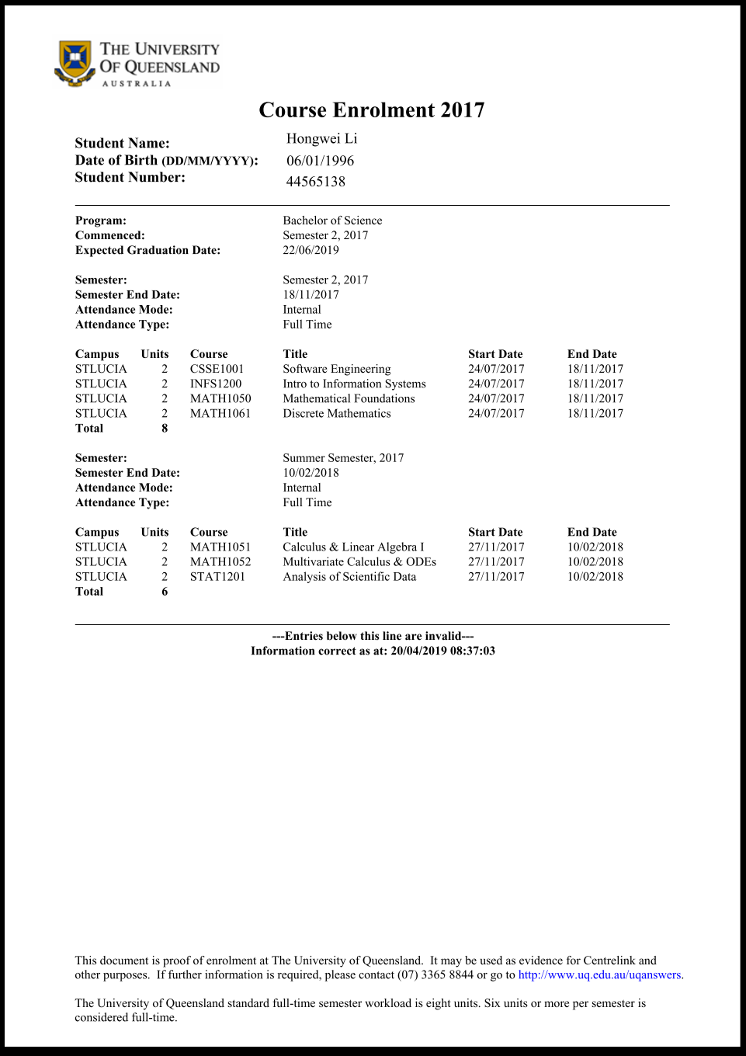

Appendix 2: Course enrolled in 2018

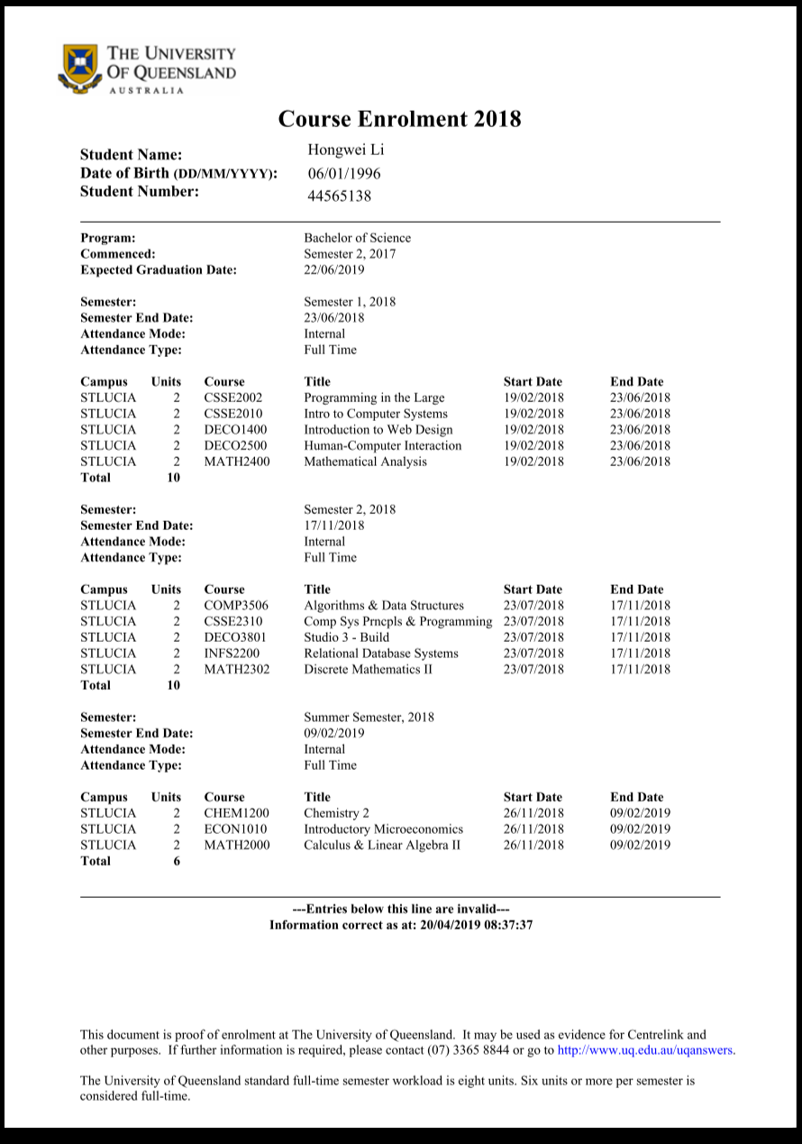

Appendix 3: Course enrolled in 2019

